**CS631008 Data Mgt Systems Design**

**Project Deliverable 2: Logical Design**

**Team Members:**

Shiva Karthik Pinjarle Manmohan

Nithin Krishna Krishnappa

Tejas Belakavadi Kemparaju

**1. Goals of this Phase:**

- Understand the requirements of the City Library system thoroughly.

- Develop a logical database design by mapping the Extended Entity-Relationship (EER) schema to a Relational schema.

- Identify any necessary revisions to the previous phase's specifications and incorporate them into the database design.

**Modified Copy of ER**

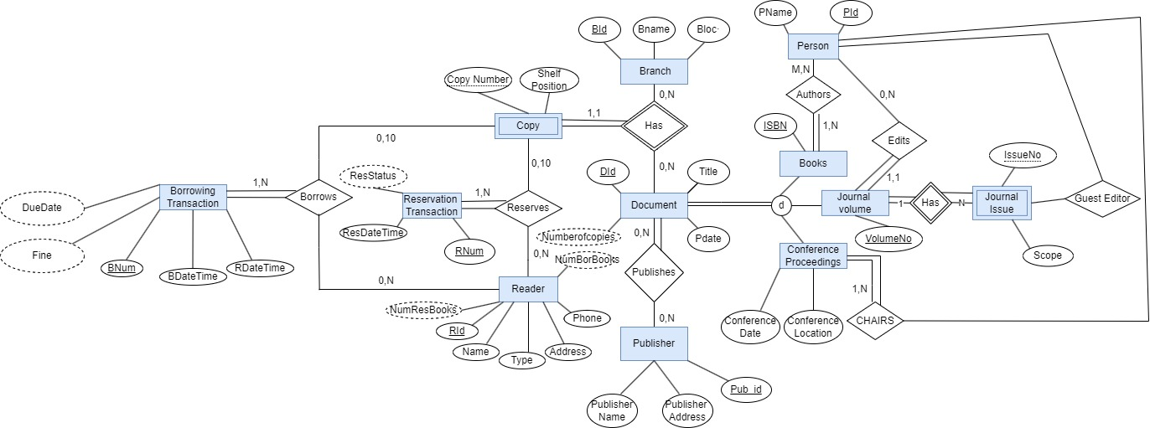

**2. EER to Relational Mapping:**

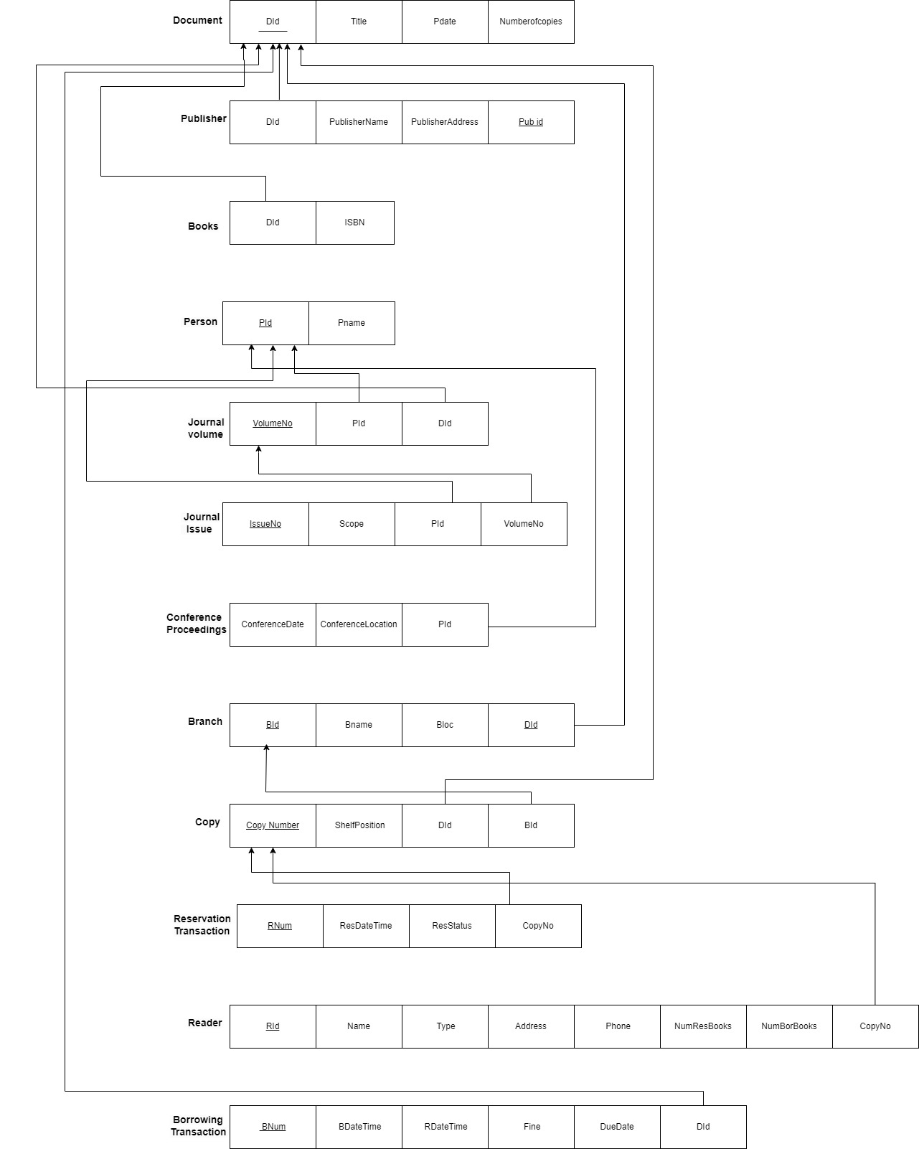

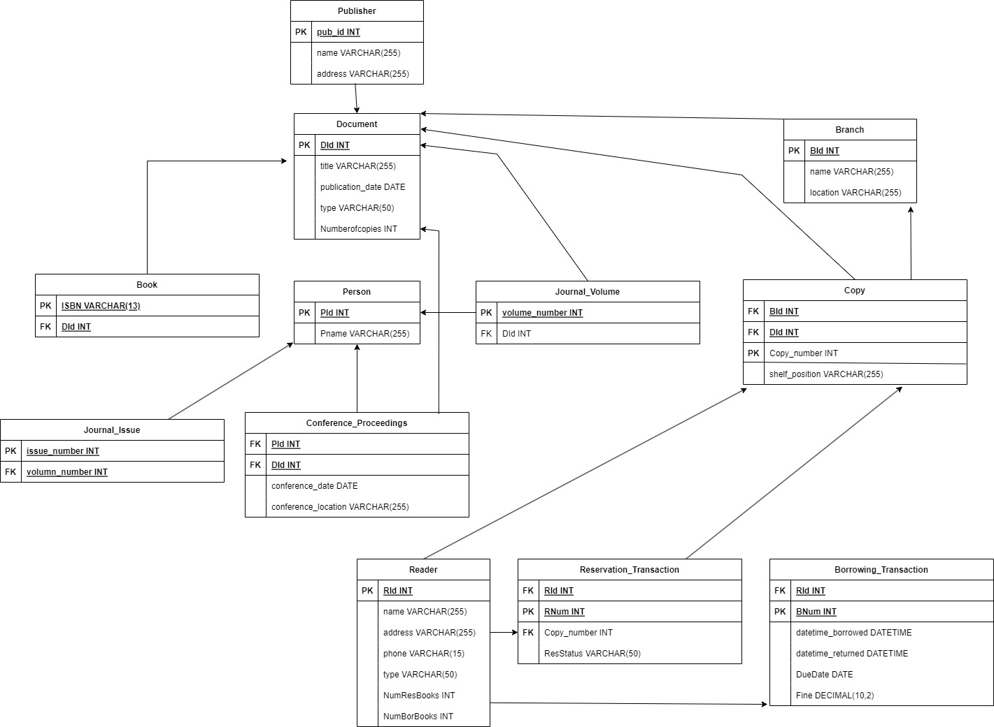

**Constraints:**

1. Document Table:

- Each document must have at least one associated publisher.

- Each document copy must be associated with a specific branch.

- A document cannot have multiple instances with the same DId.

2. Publisher Table:

- Each publisher must have published at least one document.

3. Person Table:

- Every person must have a unique PId.

4. Branch Table:

- Every branch must exist in the system.

5. Copy Table:

- Each copy must be associated with a branch.

- A copy cannot have multiple instances with the same Copy_Id.

6. Reader Table:

- Every reader must be registered in the system.

7. Reservation Table:

- Reserved copies must be picked up before 6 pm on the scheduled day, or the reservation is canceled.

- Each reservation transaction must have at least one document copy associated with it.

- A reader cannot reserve more than 10 documents simultaneously.

8. Borrowing Table:

- Each borrowing transaction must have at least one document copy associated with it.

- A reader cannot borrow more than 10 documents simultaneously.

**Logical Design**

-- Publisher Table

CREATE TABLE Publisher (

Pub_Id INT PRIMARY KEY,

name VARCHAR(255),

address VARCHAR(255),

CONSTRAINT chk_publisher_document_exists CHECK (

EXISTS (SELECT 1 FROM Document WHERE Pub_Id = Publisher.Pub_Id)

)

);

-- Person Table

CREATE TABLE Person (

PId INT PRIMARY KEY,

Pname VARCHAR(255),

CONSTRAINT uk_person_pid UNIQUE (PId)

);

-- Document Table

CREATE TABLE Document (

DId INT PRIMARY KEY,

title VARCHAR(255),

publication_date DATE,

type VARCHAR(50),

Numberofcopies INT,

Pub_Id INT,

CONSTRAINT fk_document_publisher FOREIGN KEY (Pub_Id) REFERENCES Publisher(Pub_Id),

CONSTRAINT chk_document_publisher_exists CHECK (Pub_Id IS NOT NULL),

CONSTRAINT uk_document_did UNIQUE (DId)

);

-- Book Table

CREATE TABLE Book (

DId INT PRIMARY KEY,

ISBN VARCHAR(50),

CONSTRAINT fk_book_document FOREIGN KEY (DId) REFERENCES Document(DId),

CONSTRAINT uk_book_isbn UNIQUE (ISBN)

);

-- Journal Volume Table

CREATE TABLE Journal_Volume (

DId INT PRIMARY KEY,

volume_number INT,

CONSTRAINT fk_journal_volume_document FOREIGN KEY (DId) REFERENCES Document(DId)

);

-- Journal Issue Table

CREATE TABLE Journal_Issue (

volume_number INT,

issue_number INT,

CONSTRAINT pk_journal_issue PRIMARY KEY (volume_number, issue_number),

CONSTRAINT fk_journal_issue_journal_volume FOREIGN KEY (volume_number) REFERENCES Journal_Volume(volume_number)

);

-- Conference Proceedings Table

CREATE TABLE Conference_Proceedings (

DId INT PRIMARY KEY,

conference_date DATE,

conference_location VARCHAR(255),

PId INT,

CONSTRAINT fk_conference_proceedings_person FOREIGN KEY (PId) REFERENCES Person(PId),

CONSTRAINT fk_conference_proceedings_document FOREIGN KEY (DId) REFERENCES Document(DId)

);

-- Branch Table

CREATE TABLE Branch (

BId INT PRIMARY KEY,

name VARCHAR(255),

location VARCHAR(255),

CONSTRAINT uk_branch_bid UNIQUE (BId)

);

-- Copy Table

CREATE TABLE Copy (

Copy_Id INT PRIMARY KEY,

DId INT,

BId INT,

copy_number INT,

shelf_position VARCHAR(50),

CONSTRAINT fk_copy_document FOREIGN KEY (DId) REFERENCES Document(DId),

CONSTRAINT fk_copy_branch FOREIGN KEY (BId) REFERENCES Branch(BId),

CONSTRAINT uk_copy_copyid UNIQUE (Copy_Id),

CONSTRAINT uk_copy_did_bid_copynumber UNIQUE (DId, BId, copy_number)

);

-- Reader Table

CREATE TABLE Reader (

RId INT PRIMARY KEY,

name VARCHAR(255),

address VARCHAR(255),

phone VARCHAR(20),

type VARCHAR(50),

NumResBooks INT,

NumBorBooks INT,

CONSTRAINT uk_reader_rid UNIQUE (RId)

);

-- Reservation Transaction Table

CREATE TABLE Reservation_Transaction (

RNum INT PRIMARY KEY,

RId INT,

ResStatus VARCHAR(20),

copy_number INT,

CONSTRAINT fk_reservation_transaction_reader FOREIGN KEY (RId) REFERENCES Reader(RId),

CONSTRAINT fk_reservation_transaction_copy FOREIGN KEY (copy_number) REFERENCES Copy(Copy_Id),

CONSTRAINT chk_reservation_transaction_copy_count CHECK (

(SELECT COUNT(*) FROM Reservation_Transaction WHERE RId = Reservation_Transaction.RId) <= 10

),

CONSTRAINT chk_reservation_transaction_pickup_time CHECK (

ResStatus = 'picked_up' OR ResStatus = 'canceled' OR (ResStatus = 'reserved' AND pickup_time <= '18:00')

)

);

-- Borrowing Transaction Table

CREATE TABLE Borrowing_Transaction (

BNum INT PRIMARY KEY,

RId INT,

copy_number INT,

datetime_borrowed DATETIME,

datetime_returned DATETIME,

DueDate DATE,

Fine DECIMAL(10, 2),

CONSTRAINT fk_borrowing_transaction_reader FOREIGN KEY (RId) REFERENCES Reader(RId),

CONSTRAINT fk_borrowing_transaction_copy FOREIGN KEY (copy_number) REFERENCES Copy(Copy_Id),

CONSTRAINT chk_borrowing_transaction_copy_count CHECK (

(SELECT COUNT(*) FROM Borrowing_Transaction WHERE RId = Borrowing_Transaction.RId) <= 10

)

);

**3. Difficulties Encountered:**

- Balancing the level of detail in the schema with the need for simplicity and clarity.

- Defining relationships and constraints accurately based on the given requirements.